Certificate of Analysis

General properties:
Name：NHS-PEG3400-PLA2000
Molecular Weight： 5500 Dalton
Cat.#： R-P-103002
Lot.#： RP201605006
Manufacture Date： 2016.05.06
Date of Analysis： 2016.05.06
Recommended Retest date： 2017.05.06
Stability： 12 months
Storage： -20°C in the dark
Structure
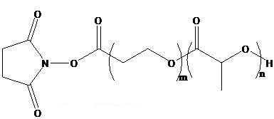

Items | Specification | Results
Appearance | White/ Light yellow solid | White solid
¹H NMR | Identical to the Structure | Identical to the Structure
Foreign Material | None | None
Substitution | ＞90% | 93%
PDI |  | <1.4
Report Date: 2016.05.06

核磁图谱：

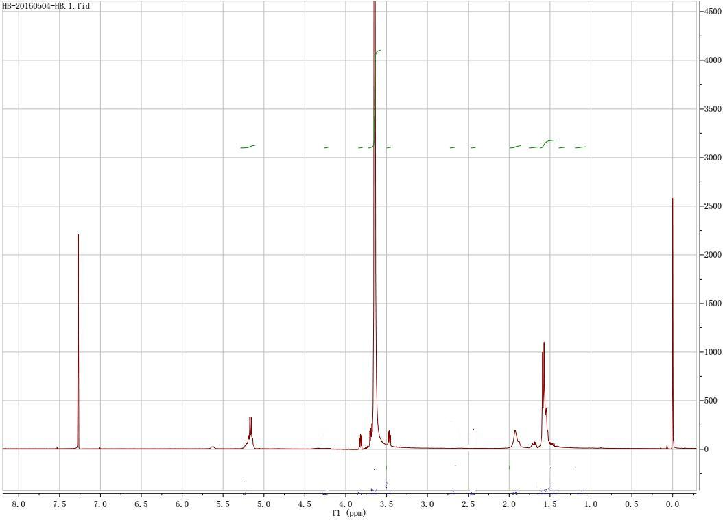

This product is for research use only, Not for human or animal use

